Title……. Bold/font size 12/ Times New Roman

Name Surname¹, Name Surname², ……(Times New Roman, 12 font, normal)

¹Address/affiliation (Times New Roman, 11 font, Italics)
²Address/affiliation

Extended Abstract Text………(font size 11/ Times New Roman/ normal) …………………………Extended Abstract Text……………… (font size 11/ Times New Roman/normal) …………………………Extended Abstract Text………………

PARAGRAPH Extended Abstract Text………(font size 11/ Times New Roman/ normal) …………………………Extended Abstract Text……………… (font size 11/ Times New Roman/normal) …………………………Extended Abstract Text………………
Acknowledgments: xyz…abc……. /font size 11/ Times New Roman.

References (not more than 5):
Keighley, D., Flint, S., Howell, J., Moscariello, A., 2003. Sequence stratigraphy in lacustrine basins: a model for part of the green river formation (eocene), southwest Uinta Basin, Utah, U.S.A. Journal of Sedimentary Research 73, 987–1006.
Saller, A., Rushton, S., Buambua, L., Inman, K., McNeil, R., Dickson, J.T., 2016. Presalt stratigraphy and depositional systems in the Kwanza Basin, offshore Angola. AAPG Bulletin 100, 1135–1164.
……..
…….

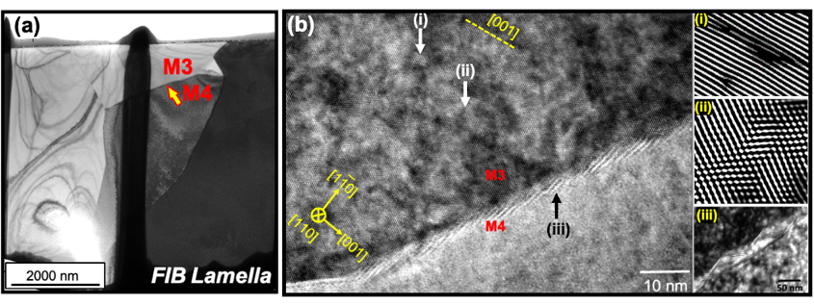
Fig. 1: (a) …text……… (b) ……….text………… font size 11/ Times New Roman…..
……

General Instructions

- Text Font size = 11
- Font = Times New Roman
- Line Spacing = single
- Number of References = Maximum 5 references (follow style of Sedimentary Geology or Journal
of Marine and Petroleum Geology, Elsevier)
- Total word Limit = 1000 (including abstract + acknowledgments + references).
- Number of Figures = Maximum 2 (TWO) (Colour figures will be printed in Colour)
- Placement of Figures = After References (maximum upto 02 figures)
- Figure Captions = Below individual figure

